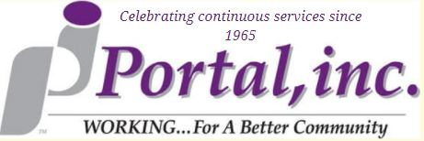
Wish List December 2021
**: Denotes items which we are only looking for one of. If you wish to purchase any items with this denotation, please contact us prior to ensure it has not been purchased by another donor.
- Old Keys
  - All sizes
  - Includes skeleton and car keys
- Acrylic Paints
- Small Canvases
- Medium Canvases
- Tacky Glue
- Modge Podge
- Window Markers
- Glue Gun sticks
- Paint pens

